3.4.6.4 Tessellation
# Source: AI Source: Provided by: [Data Path: Persons Table -> ID Column: 1, Name_En Column: Motasem Essam] -> From: [ChatGPT] on [7/25/2026]
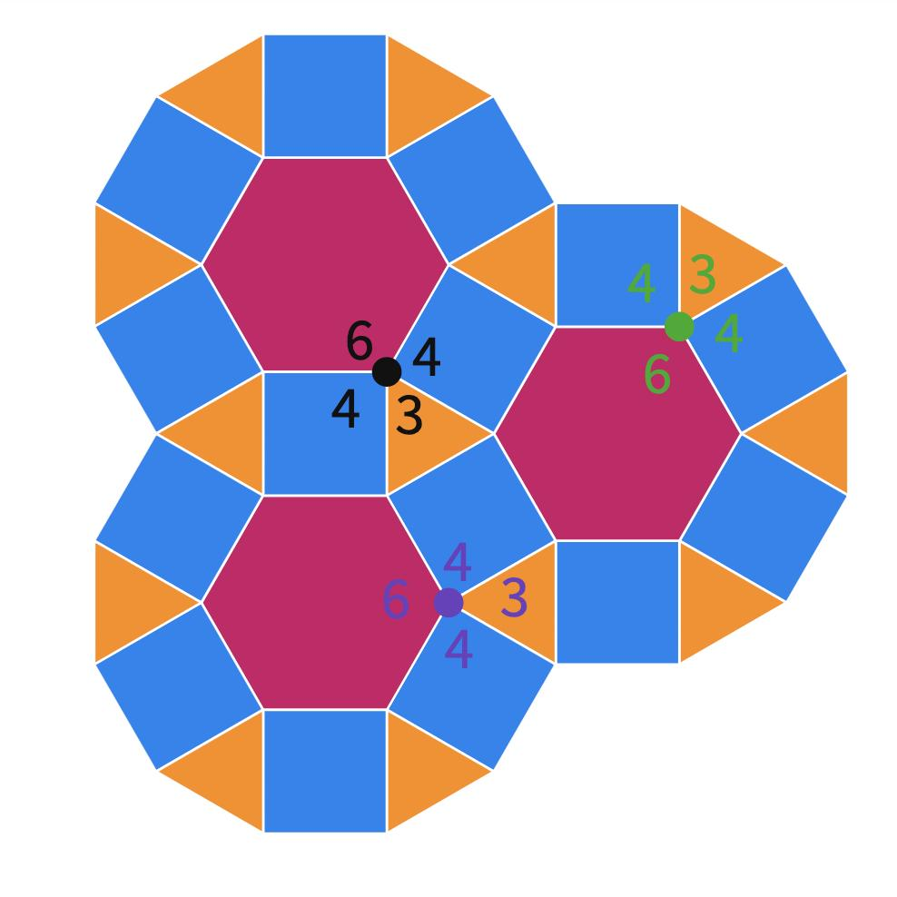
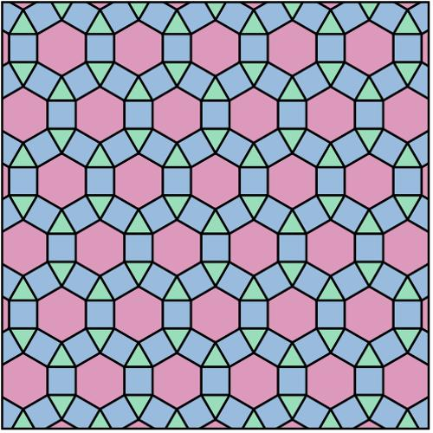
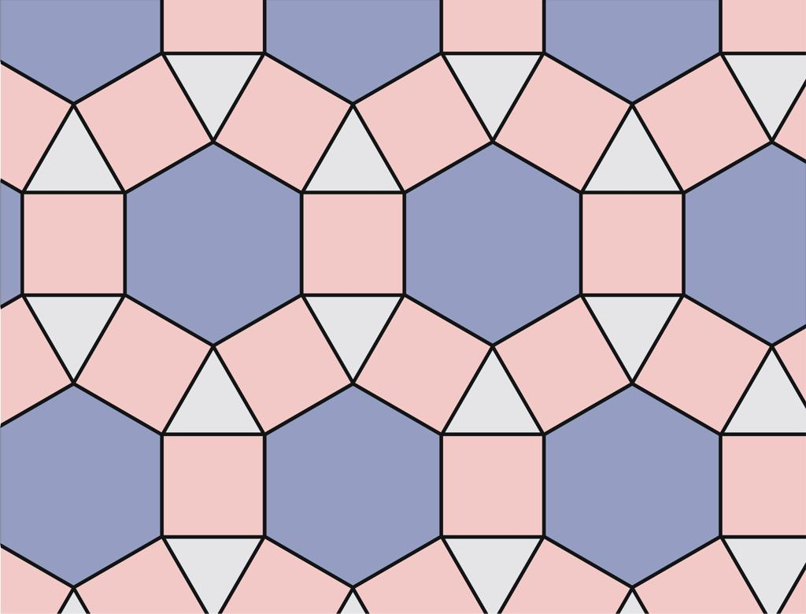
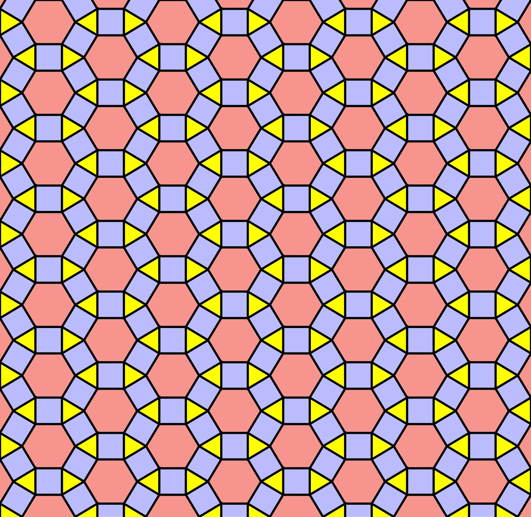
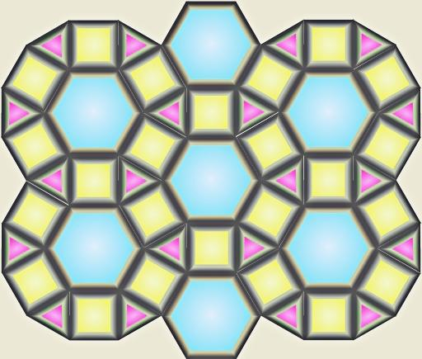
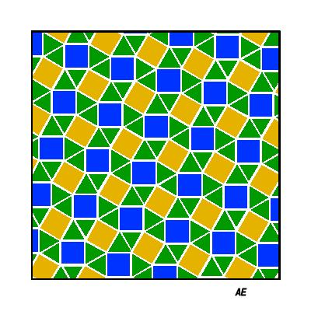
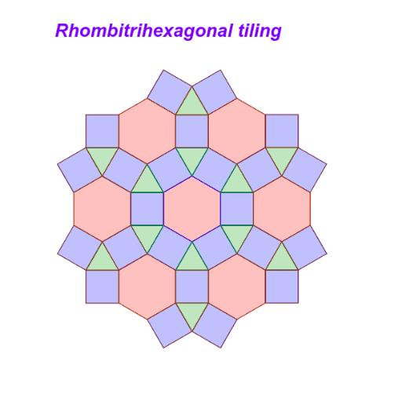

Definition
# Source: AI Source: Provided by: [Data Path: Persons Table -> ID Column: 1, Name_En Column: Motasem Essam] -> From: [ChatGPT] on [7/25/2026]
The 3.4.6.4 tessellation is a semi-regular (Archimedean) tessellation of the Euclidean plane composed of equilateral triangles, squares, and regular hexagons.
Its vertex configuration is:
$$\boxed{3.4.6.4}$$
This means that, around every vertex, the polygons occur in the cyclic order:
Triangle → Square → Hexagon → Square
So every vertex has:
- 🔺 1 equilateral triangle
- 🟦 2 squares
- ⬡ 1 regular hexagon

Classification
# Source: AI Source: Provided by: [Data Path: Persons Table -> ID Column: 1, Name_En Column: Motasem Essam] -> From: [ChatGPT] on [7/25/2026]
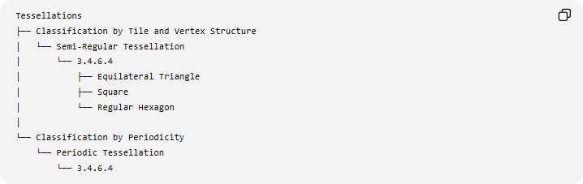
Tessellations
├── Classification by Tile and Vertex Structure
│ └── Semi-Regular Tessellation
│ └── 3.4.6.4
│ ├── Equilateral Triangle
│ ├── Square
│ └── Regular Hexagon
│
└── Classification by Periodicity
└── Periodic Tessellation
└── 3.4.6.4
Therefore:
$$\boxed{\text{3.4.6.4 is Semi-Regular and Periodic}}$$

Fundamental Elements
# Source: AI Source: Provided by: [Data Path: Persons Table -> ID Column: 1, Name_En Column: Motasem Essam] -> From: [ChatGPT] on [7/25/2026]
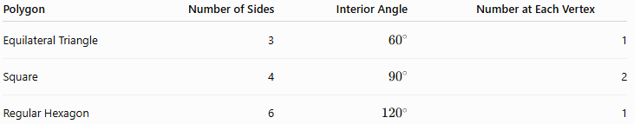
Polygon | Number of Sides | Interior Angle | Number at Each Vertex
Equilateral Triangle | 3 | $${60}^{∘}$$ | 1
Square | 4 | $${90}^{∘}$$ | 2
Regular Hexagon | 6 | $${120}^{∘}$$ | 1
Thus, four polygons meet at every vertex:
$$\boxed{1\text{ triangle}+2\text{ squares}+1\text{ hexagon}}$$

Vertex Angle Verification
# Source: AI Source: Provided by: [Data Path: Persons Table -> ID Column: 1, Name_En Column: Motasem Essam] -> From: [ChatGPT] on [7/25/2026]
The angles around every vertex are:
$${60}^{∘}+{90}^{∘}+{120}^{∘}+{90}^{∘} \\ ={360}^{∘}$$
Therefore:
$$\boxed{{60}^{∘}+{90}^{∘}+{120}^{∘}+{90}^{∘}={360}^{∘}}$$
The polygons completely fill the plane without gaps or overlaps.

Visual Structure
# Source: AI Source: Provided by: [Data Path: Persons Table -> ID Column: 1, Name_En Column: Motasem Essam] -> From: [ChatGPT] on [7/25/2026]
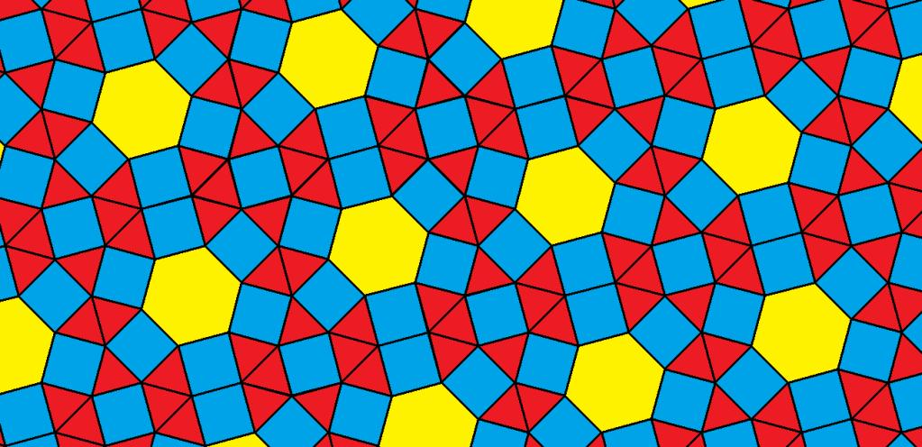
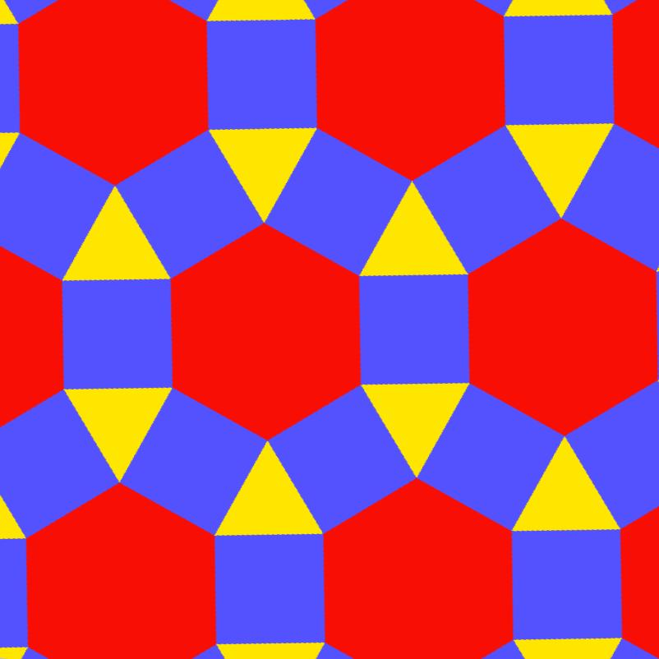
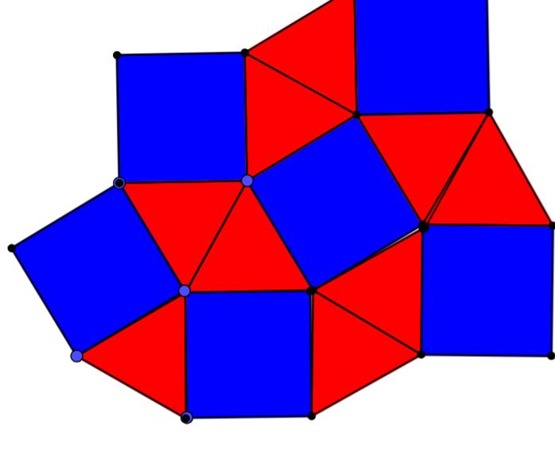
The repeating pattern can be viewed as:
⬡
/ \
□ □
\ /
🔺
with the arrangement continuing throughout the plane.
A full mathematical tiling is shown by Wikimedia Commons as a repeating arrangement of triangles, squares, and hexagons.

Vertex Configuration
# Source: AI Source: Provided by: [Data Path: Persons Table -> ID Column: 1, Name_En Column: Motasem Essam] -> From: [ChatGPT] on [7/25/2026]
The notation
$$\boxed{3.4.6.4}$$
describes the number of sides of the polygons encountered cyclically around a vertex:
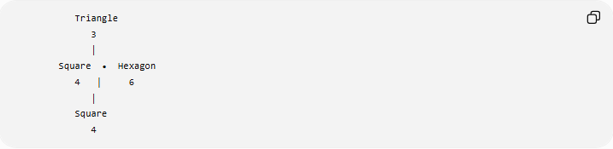
Triangle
3
│
Square • Hexagon
4 │ 6
│
Square
4
So the sequence is:
$$\boxed{3→4→6→4}$$
The two squares are separated by the triangle and hexagon in the cyclic arrangement.

Why It Is Semi-Regular
# Source: AI Source: Provided by: [Data Path: Persons Table -> ID Column: 1, Name_En Column: Motasem Essam] -> From: [ChatGPT] on [7/25/2026]
The tessellation satisfies the conditions for a semi-regular tessellation:
- It uses regular polygons.
- It uses more than one type of regular polygon.
- The same vertex configuration occurs at every vertex.
- The polygons meet edge-to-edge.
- There are no gaps or overlaps.
Therefore:
$$\boxed{\text{3.4.6.4 is a Semi-Regular Tessellation}}$$

Why It Is Not Regular
# Source: AI Source: Provided by: [Data Path: Persons Table -> ID Column: 1, Name_En Column: Motasem Essam] -> From: [ChatGPT] on [7/25/2026]
A regular tessellation uses only one type of regular polygon.
The $3.4.6.4$tessellation uses three different polygon types:
$$\boxed{\text{Triangle}+\text{Square}+\text{Hexagon}}$$
Therefore, it is not a regular tessellation.

Periodicity
# Source: AI Source: Provided by: [Data Path: Persons Table -> ID Column: 1, Name_En Column: Motasem Essam] -> From: [ChatGPT] on [7/25/2026]
The $3.4.6.4$tessellation repeats its structure throughout the plane.
It therefore has translational symmetry and is classified as a periodic tessellation:
$$\boxed{\text{Semi-Regular}+\text{Periodic}}$$

Mathematical Representation
# Source: AI Source: Provided by: [Data Path: Persons Table -> ID Column: 1, Name_En Column: Motasem Essam] -> From: [ChatGPT] on [7/25/2026]
The interior angle of a regular $n$-gon is:
$$θ=\frac{\left(n-2\right){180}^{∘}}{n}$$
For the three polygons:
Equilateral Triangle
$$θ_{3}={60}^{∘}$$
Square
$$θ_{4}={90}^{∘}$$
Regular Hexagon
$$θ_{6}={120}^{∘}$$
At a vertex:
$$θ_{3}+θ_{4}+θ_{6}+θ_{4}={360}^{∘}$$
Therefore:
$$\boxed{{60}^{∘}+{90}^{∘}+{120}^{∘}+{90}^{∘}={360}^{∘}}$$

Comparison with Other Semi-Regular Tessellations
# Source: AI Source: Provided by: [Data Path: Persons Table -> ID Column: 1, Name_En Column: Motasem Essam] -> From: [ChatGPT] on [7/25/2026]
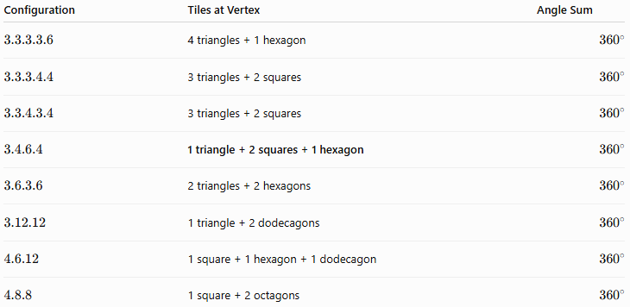
Configuration | Tiles at Vertex | Angle Sum
$$3.3.3.3.6$$ | 4 triangles + 1 hexagon | $${360}^{∘}$$
$$3.3.3.4.4$$ | 3 triangles + 2 squares | $${360}^{∘}$$
$$3.3.4.3.4$$ | 3 triangles + 2 squares | $${360}^{∘}$$
$$3.4.6.4$$ | 1 triangle + 2 squares + 1 hexagon | $${360}^{∘}$$
$$3.6.3.6$$ | 2 triangles + 2 hexagons | $${360}^{∘}$$
$$3.12.12$$ | 1 triangle + 2 dodecagons | $${360}^{∘}$$
$$4.6.12$$ | 1 square + 1 hexagon + 1 dodecagon | $${360}^{∘}$$
$$4.8.8$$ | 1 square + 2 octagons | $${360}^{∘}$$

Important Distinction
# Source: AI Source: Provided by: [Data Path: Persons Table -> ID Column: 1, Name_En Column: Motasem Essam] -> From: [ChatGPT] on [7/25/2026]
The $3.4.6.4$configuration contains four polygons around each vertex, not five.
$$\boxed{3+4+6+4\text{ represents four polygons}}$$
The numbers represent the number of sides of each polygon, not the number of polygons.
Thus:
- $3$→ one triangle
- $4$→ one square
- $6$→ one hexagon
- $4$→ another square

Key Properties
# Source: AI Source: Provided by: [Data Path: Persons Table -> ID Column: 1, Name_En Column: Motasem Essam] -> From: [ChatGPT] on [7/25/2026]
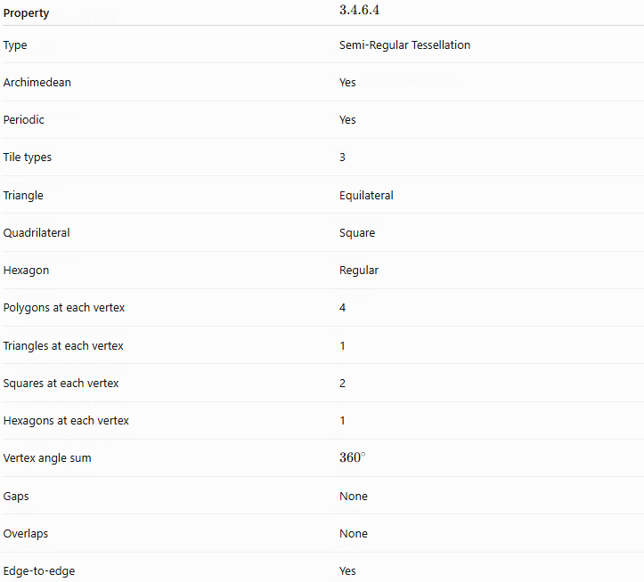
Property | $$3.4.6.4$$
Type | Semi-Regular Tessellation
Archimedean | Yes
Periodic | Yes
Tile types | 3
Triangle | Equilateral
Quadrilateral | Square
Hexagon | Regular
Polygons at each vertex | 4
Triangles at each vertex | 1
Squares at each vertex | 2
Hexagons at each vertex | 1
Vertex angle sum | $${360}^{∘}$$
Gaps | None
Overlaps | None
Edge-to-edge | Yes

Relationship to the Eight Semi-Regular Tessellations
# Source: AI Source: Provided by: [Data Path: Persons Table -> ID Column: 1, Name_En Column: Motasem Essam] -> From: [ChatGPT] on [7/25/2026]
The $3.4.6.4$tessellation is one of the eight Archimedean tessellations:
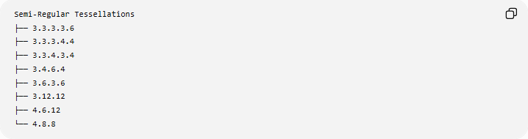
Semi-Regular Tessellations
├── 3.3.3.3.6
├── 3.3.3.4.4
├── 3.3.4.3.4
├── 3.4.6.4
├── 3.6.3.6
├── 3.12.12
├── 4.6.12
└── 4.8.8

Key Points
# Source: AI Source: Provided by: [Data Path: Persons Table -> ID Column: 1, Name_En Column: Motasem Essam] -> From: [ChatGPT] on [7/25/2026]
- 3.4.6.4 is a semi-regular (Archimedean) tessellation.
- It contains equilateral triangles, squares, and regular hexagons.
- Exactly four polygons meet at each vertex.
- The cyclic order is:
$$\boxed{3→4→6→4}$$
- The angles are:
$${60}^{∘}, {90}^{∘}, {120}^{∘}, {90}^{∘}$$
- Their sum is:
$$\boxed{{360}^{∘}}$$
- It is also periodic.
- The two squares are distinct positions in the cyclic vertex configuration.

Conclusion
# Source: AI Source: Provided by: [Data Path: Persons Table -> ID Column: 1, Name_En Column: Motasem Essam] -> From: [ChatGPT] on [7/25/2026]
The 3.4.6.4 tessellation is a semi-regular, periodic tessellation in which one equilateral triangle, two squares, and one regular hexagon meet at every vertex in the cyclic order
$$\boxed{3.4.6.4}$$
Their interior angles sum exactly to ${360}^{∘}$, allowing the polygons to cover the Euclidean plane completely without gaps or overlaps.

